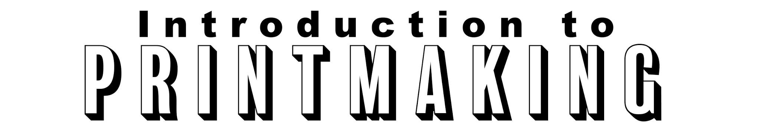Teacher: Mr. Clyde Ashby RM: # 114
E-MAIL: cashby@rootshigh.org

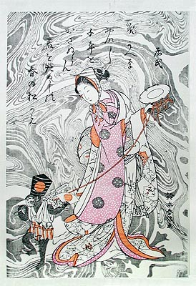
Course Description
This class will introduce students to the printmaking processes of Relief block printing, Monotypes, Monoprints, and Screen Printing.

Printmaking is the process of creating original works of art that exist as multiples in a set called an edition. For example, one print would not be considered the work of art, it is the entire edition of prints. However, Monotypes are created by using multiple printmaking techniques to make similar but not exactly identical prints.

Course Objectives
Students will:
1. Create editions of prints utilizing one or more print techniques that demonstrate both technical and conceptual consideration.
2. Learn and apply different printmaking techniques and processes with proficiency.
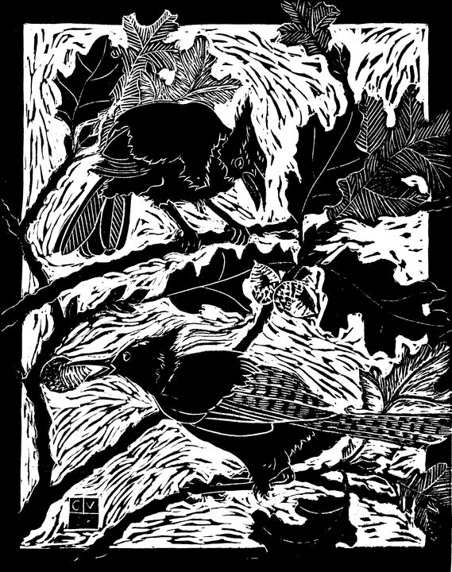
3. Analyze and evaluate their own work and that of other students through the process of critique using terms and concepts appropriate to the medium.
4. Understand the history of printmaking as a distinctive form of art production.
5. Practice and apply the traditions and terminology of original print production

Section 1: Relief block printing
Originating in the 8th century in the far east, and the 15th century in the west; a relief print can be made from any flat, carvable surface. Traditionally they are created using a wood or linoleum plate, also called a block. Knives, gouges, or engraving tools, are used to develop a variety of shapes, lines, and textures. The areas that have been carved away will not print as the ink will
only be rolled or inked on the raised surface. This unprinted negative space will remain the color of the paper. Once the plate has been cut and the surface rolled up with ink, the paper is placed over the plate. Pressure is then applied by hand, with a burnishing tool, or a press.

1 - color printing
Reduction printing - multicolored
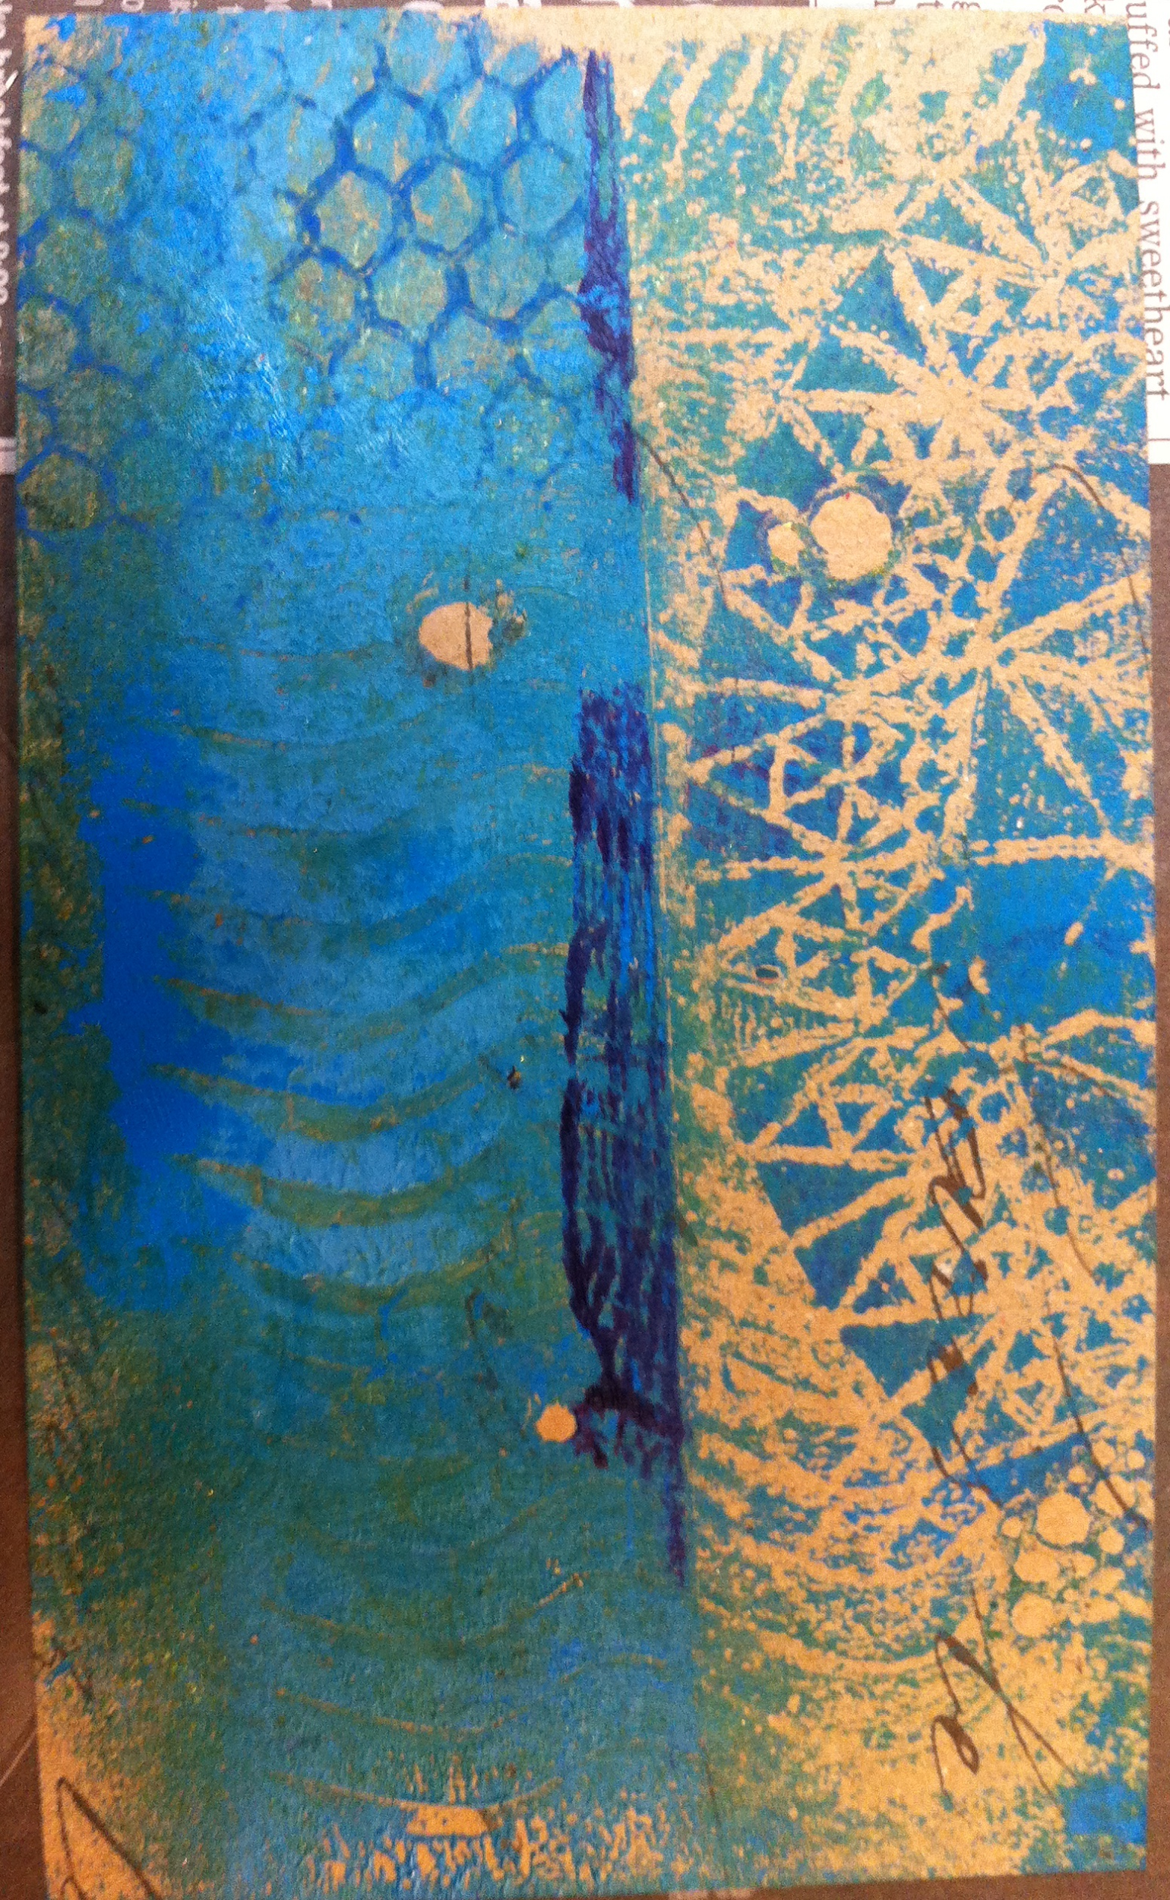
Section 2: Monoprints and Monotypes
Monoprints and Monotypes are generally considered the most painterly printmaking processes. In a way, you are printing a painting. They are non-editionable prints because the images and lines usually cannot be exactly reproduced and no two prints end up being perfectly alike. The beauty of this medium is in its spontaneity and its combination of printmaking, painting and drawing media. The process offers an opportunity to explore color separations and transitions, hand rubbing, mark making, tone, and texture.

Monotypes and monoprints are different. Monotype is a planographic process. The matrix, or plate, is flat and featureless. This means it contains nothing that will pass on any characteristics to the prints. Because there are no permanent features on the plate, all imagery relies on the artist working with the ink to create one distinctive print.
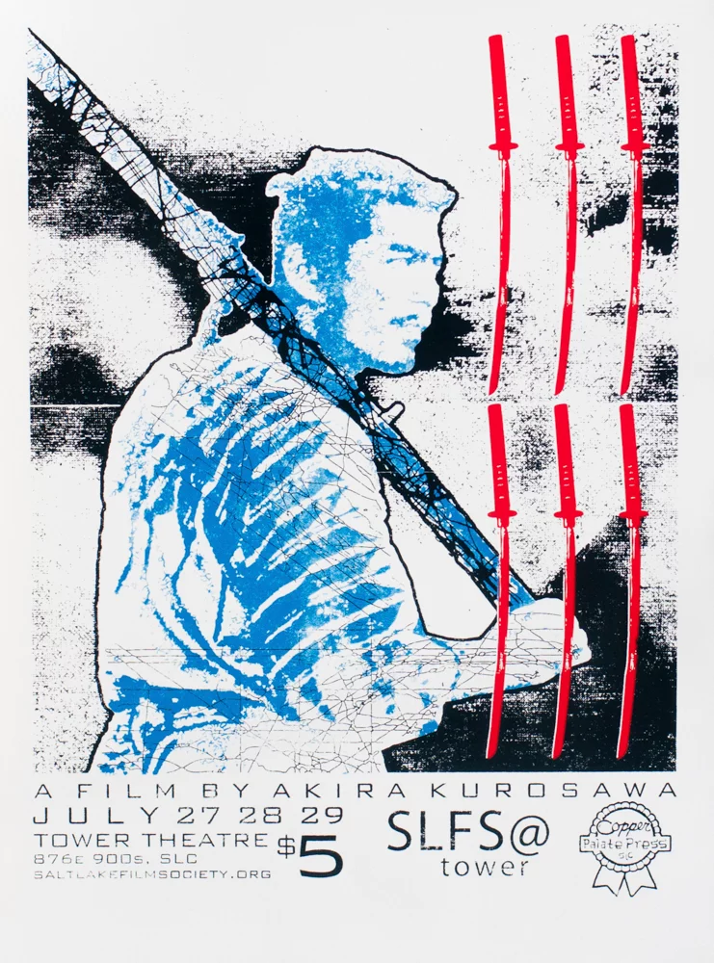
Section 3: Screen Printing
Screen printing is a printing technique whereby a mesh is used to transfer ink onto a flat surface, except in areas made impermeable to the ink by a blocking stencil. It is also a stencil method of printmaking in which a design is imposed on a screen of polyester or other fine mesh, with blank areas coated with an impermeable substance. Ink is forced into the mesh openings by a squeegee and transferred onto the printing surface.

Grading:
Grades will be based on Attendance, Citizenship - on task, and completed Assignments. Each of the categories is worth a third of your grade. If you want to discuss your grades with me, please see me during my available times before or after
school.

Attendance:
Attendance is a third of your grade; please attend class as much as possible. Students automatically earn 10 points per class for showing up on time. If you are tardy in the first 5 minutes you lose 5 of those points. You can still lose points if you are not on task, or being disrespectful to others and the learning experience, and eating food while using the school’s computers. So show up on time and participate in class assignments, and respect others and the class culture.

Also, since we are using school computers, and if you do not have a home computer, get as much work done in class and complete assignments on time. We will always have several classes to work on and complete assignments before due dates. Please see my available hours for after school tutoring and assistance in the information at the bottom of this page.

Tutoring and Help Sessions:
I am available to discuss grades or missing work, and for tutoring and help on Mondays through Thursdays, from 3:15 pm to 4 pm, and after school on Fridays until 4 pm. Other meetings (mornings) or tutoring help will have to be made by appointment with me 24 hours in advance in person or by email.

Cell Phones
Please do not use cell phones at all during instructional periods of class. You will receive one warning for phone infractions, the second time I take your phone until the end of class, third infraction is when your phone goes to the office for the day. I do allow students to listen to music with one ear bud during studio work times.

